Properties

League Tab

League Name: Enter the name of your league. This appears on most reports produced by Pool League Manager. The maximum field length is 40 characters. Example ‘Wellington & District Pool League’.

Season: Enter the season. This can be simply a year or perhaps ‘Winter 2000’. The maximum field length is 20 characters.

Calculations Tab

All the properties on this tab relate to the production of singles and doubles ratings. These properties combine to produce the player and pair ratings following the Pool League Manager update.

Latest Frame Weighting: This is an integer representing the value of the most recent frame a player/pair completes in.

Weighting Decreases By: Another integer value representing the value by which the weighting of the second most recent and all previous frames drop.

Ratings Include Last n Games Played: An integer representing the number of frames used to calculate a player/pairs rating.

Qualify After n Games Played: An integer value representing the number of games a player/pair must play before qualifying for a rating.

Calculations Tab Example:

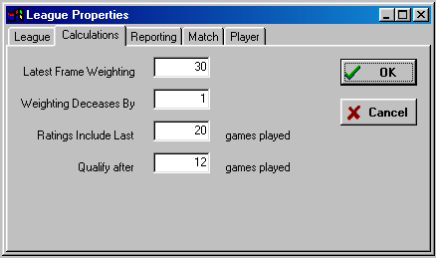In the above example, a player/pair will receive a rating only after completing 12 games. The value of the most recent frame is worth 30, second most recent 29 (dropping by 1) until the twentieth most recent, which will be worth 11. The 21st most recent and all older games are disregarded as far as ratings are concerned. This is an example of a rating that is biased towards ‘recent form’.

Here are some examples of other settings and their effect on the ratings calculations:

Latest Frame Weighting | Weighting Decreases By | Ratings Include Last n Games Played | Effect
30 | 1 | 20 | Main Example as above. Biased towards the most recent of the last 20 frames (1st frame worth 30, 20th frame worth 11 (approx. 33% of first).
40 | 1 | 20 | As main example but slightly less bias towards current form (1st frame worth 40, 20th frame worth 21 (approx. 50% of first)
20 | 1 | 20 | As main example but slightly more bias towards current form (1st frame worth 20, 20th frame worth 1 (approx. 5% of first)
60 | 2 | 20 | Exactly the same as main example
100 | 1 | 100 | Slightly biased towards the most recent frames but across a full season (100 frames assumed as a maximum)
1 | 1 | 20 | Each frame receives the same value across the last twenty frames
1 | 1 | 999 | As above, but all frames considered and therefore represents ‘season-long form’.

